|  |  |  |
| --- | --- | --- |
| VJAS Voice | | Winter Issue  March 2020 |
| *The Virginia Junior Academy of Science’s Quarterly Publication* | | |
| *Happy New Decade! VJAS Voice has prepared several articles reflecting on the last year and introducing the excitement of the new decade. Learn about events in science, and hear from members of the VJAS community!*  ***-Noah Portner,***  ***Karly Ramnani***  ***VJAS Student Government***  ***President:*** *Shan Lateef*  ***Vice President:*** *Claire Morton*  ***Secretary:*** *Abhi Kulkarni*  ***Co-Editors in Chief:*** *Noah Portner, Karly Ramnani*  ***Communications Liasion:*** *Christopher Marotta*  Lightbulb, plug and globe graphic | Image result for COVID-19VJAS Changes for 2020 Symposium Dear Fellow Scientists,  It is indeed a huge disappointment that the annual VJAS symposium will no longer occur in its usual format. Due to the ongoing pandemic of COVID-19, VJAS leadership has decided to cancel the physical portion of the 2020 VJAS Research Symposium & Annual meeting. This was not an easy decision for them to make, but given the current circumstances, it is the best way forward for the health and safety of everyone involved.  However, we will proceed with the VJAS competition and judging based solely on the submitted research papers. For further information please visit our website at <https://vjas.org/index.html>  While this is devastating for sure, what this has taught me is the importance of ongoing scientific research and staying ready to apply scientific principles at a moment's notice. Times like this make me proud to be a part of VJAS whose mission is to groom the future scientists of the world. We look forward to remaining connected with you through the competition phase and hope to see many of you next year.  Stay healthy,  Shan Lateef  VJAS Student Officer and President | |

## Preview on AJAS and NAAS

*This report was written by President Shan Lateef, who attended the convention with three others.*

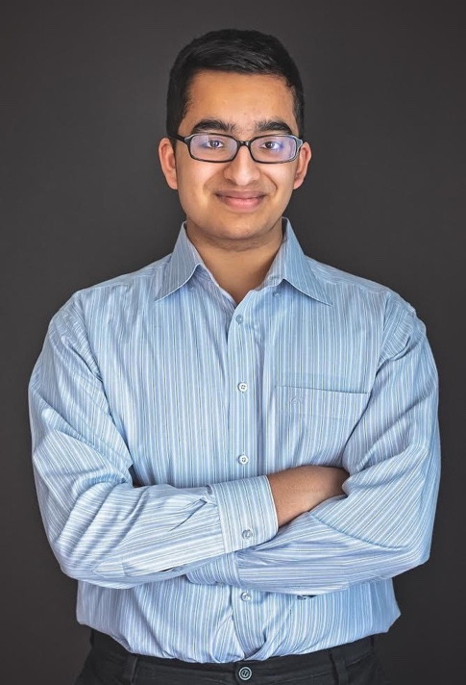

*Shan Lateef, 2020 AJAS attendee*

**Science in Seattle!**

The National Association of Academies of Science (NAAS) and the American Junior Academy of Science (AJAS) convened February 12-16, 2020 at the Sheraton Grand in Seattle. Junior Academy delegates chosen by their AAAS Affiliated Science Academy, were invited to attend. Representing the Virginia delegation were 4 awardees who received the Best of Symposium Award during the VJAS 2019 Symposium at Old Dominion University: Desmen Boykin (Graham Park Middle School), James Licato (Washington-Lee High School), Maria Stuebner (New Horizons Governor School) and Shan Lateef (Thomas Jefferson High School for Science and Technology). The Convention included an opening reception, tours, breakfast with Scientists, poster sessions, oral presentations, and the AJAS honors banquet. The experience was very rewarding and exciting so please stay tuned for an in-depth report in our next VOICE issue!

-*Shan Lateef*

Hear From VJAS Attendees

*VJAS officers interviewed current highschoolers and graduated VJAS alumni from various schools and universities both in and out of state. We hoped to create a dialogue of change for the new decade, not just in our symposium but in the overall field of science.*

**Allyson Wang – Godwin High School, 11th grade**

**1st Place in Statistical Analysis & Inferences; Statistics Award**

**Project Title: Regression Modeling of US Health Care Costs**

**What do you believe the real world value of your project is? How can research like what you did be used to improve science in the future?**

Many families in the U.S. struggle to pay for rising health care costs, which is driven by factors such as the increase in population, pharmaceutical costs, and diseases. The objective of my research was to use regression analysis to determine the role of each factor towards the increase of health spending. My research can help health officials improve policies to lower consumer costs and help families pay for health care.

**What did you enjoy most about your experience at VJAS?**

I enjoyed attending VJAS because not only was I able to present my project and learn from professionals, but it was also an opportunity to bond with my friends and teachers over science.

**How did it feel to win?**

It was extremely exciting and also rewarding. Winning also motivated and inspired me to continue my passion in applying statistics to solve real world problems.

**What are your new year's resolutions - science related and not science related?**

I hope to be involved in at least one scientific/statistical research project this year to gain a better understanding in applying my learned skills to the real world. Another New Year’s resolution of mine is to learn something new every day.

**What changes would you like to see in VJAS for the coming symposium, and decade?**

For future VJAS symposiums, it would be eye-opening for students to have time set aside to talk with professors attending the fair. Students would be able to learn about possible future careers and internships.

**Where do you see yourself, and the field of science, in general, at the end of this decade?**

By the end of the decade, I see myself collaborating with others in using statistics to help the advancement of the field of science. I hope to make a difference in the science community. In the future, with technological advancements improving exponentially, science will be crucial in creating new medicine, developing new devices, and reducing climate change. Scientists play inspiring and influential roles in society economically and socially to help innovate solutions and products for our future.

**Kayla Holston**

Ms. Holston presented at VJAS in 2013 and served as the VJAS Communications Liaison from 2013-2014. She has also served as a Judge and Judge Chair. She earned a Bachelor of Science in Biomedical Engineering and Cognitive Science in 2018, and a Master of Public Health in Health Care Management in 2019. Currently, she is an MD candidate at the Medical College at Thomas Jefferson University.

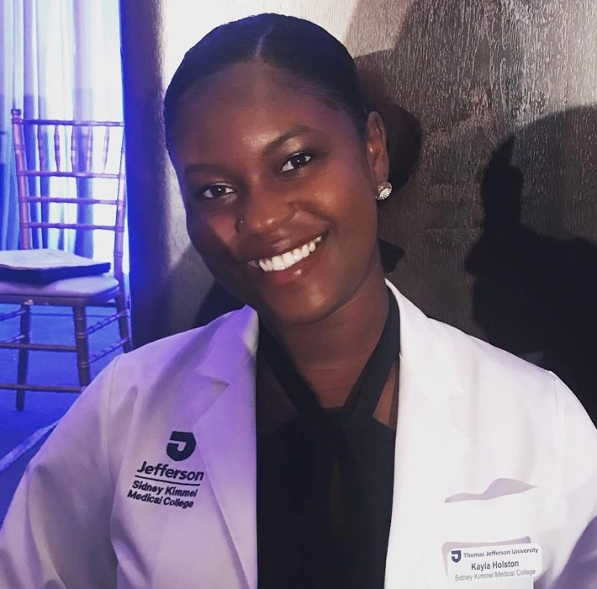**Q: What are your career aspirations?**

A: I aspire to practice medicine in a surgical/procedural field and also serve in an administrative position focused on efficiency and quality. In other words, I would like to affect patients on both the individual and broader policy level. Ultimately, I hope to serve in a physician leadership position such as Chief Medical Officer for a health system.

**Q: How do you think your involvement in VJAS benefitted you?**

A: Presenting at VJAS exposed me to leaders in the science community and pushed me to think more critically about what my research results meant. The questions and advice from judges prepared me to think analytically in future research studies in college and beyond. The leadership experience with VJAS was also invaluable, as I had the opportunity to be involved in running a conference, giving a welcome address, adapting to changing needs, and providing advice to emerging scientists.

**Q: What was your most memorable experience in science?**

A: My most memorable VJAS experience was giving the welcome address to students in 2014. I witnessed firsthand the excitement of young scientists to share their findings, be recognized for their hard work, and network with peers also leading the way in scientific research. I felt privileged to be the first face of VJAS that students saw, and to welcome them to a series of events that would undoubtedly be a formative experience for them.

**Q: Do you have any advice for current VJAS members and officers?**

A: Before you do a research project, think hard about what you are passionate about. What relates to your daily or family life? What have you always wondered about? Students tend to spend a lot of time researching what they think will get them accolades or what someone tells them data is already available for. However, I have found that we do our best work when we are passionate about the topic. I think Steve Jobs says it best: *“Your work is going to fill a large part of your life, and the only way to be truly satisfied is to do what you believe is great work. And the only way to do great work is to love what you do. If you haven't found it yet, keep looking. Don't settle. As with all matters of the heart, you'll know when you find it.”*

**Q: Anything else you’d like to share?**

A: Students are welcome to contact me with questions or requests for advice regarding research (I’m involved in international medical research and surgical research), medical school, public health, college, and anything else on their minds. Just include VJAS in the subject line and email [kayla.holston@jefferson.edu](mailto:kayla.holston@jefferson.edu)!

**Pakriti Verma**

Ms. Verma presented at VJAS from 2005-2008 and served as the VJAS Secretary and President from 2007-2009. She is a 2013 graduate from the University of Virginia with a degree in Computer Science.

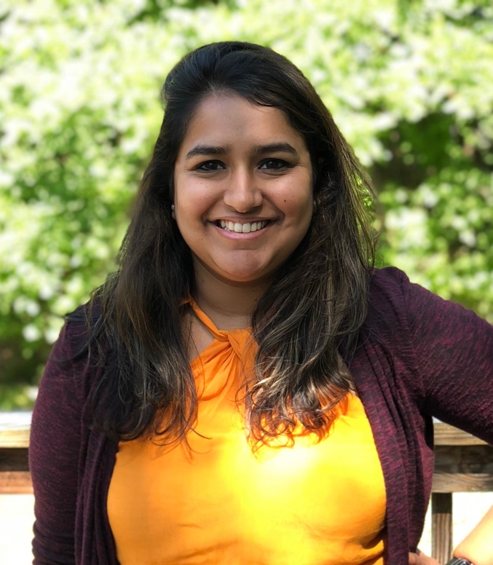**Q: What are your career aspirations?**

A: Currently I work for Red Hat - the leading provider of enterprise open source solutions - as the North America Agile Lead in our Consulting Project Management Office.  Essentially, I get to teach and enable the project managers and technical experts on using innovative collaboration practices to drive and facilitate conversations with customers. In the next five years, I’d love to expand this role to build this capability across our organization at a global level.

**Q: How do you think your involvement in VJAS benefitted you?**

A: VJAS helped build the soft skills that have set me up for the successes I’ve had to date.  As a scientist, I learned the importance of keeping a mentality of experimentation and using every observed impact as a learning opportunity.  As a presenter, I grew more comfortable with public speaking and learning how to share my experiences in a consumable way to the audience. And, lastly, as an officer, practicing my leadership skills developed me into the managing role I’m in today.

**Q: What was your most memorable experience in science?**

A: My entire life has been around science and technology.  I remember in school how excited I was to learn about the scientific method and creating Experimental Design Diagrams.  I loved how applicable to everyday situations it could be, by breaking down experiences into experiments and learning opportunities.  This mentality is what created the foundation of continuous learning in me, which is one of the core concepts of Agile and one of the main capabilities I encourage and develop with clients.

**Q: Do you have any advice for current VJAS members and officers?**

A: Enjoy it! Make connections and learn and absorb everything you can.

**Q: Anything else you’d like to share?**

A: Use science as much as you can to find your passion, and then channel that passion to leave society better than we came into it. Cannot wait to see where the next set of scientists leads us in the world.

VJAS VOICE